RESOLUTION NO.__________

RE: CERTIFICATE OF APPROPRIATENESS UNDER THE

PROVISIONS OF THE ACT OF THE PENNSYLVANIA

LEGISLATURE 1961, JUNE 13, P.L. 282 (53

SECTION 8004) AND BETHLEHEM ORDINANCE NO.

3952 AS AMENDED.

WHEREAS, it is proposed to strip and repaint the existing trim and decorative woodwork on the west façade at 407-409 VineStreet.

NOW, THEREFORE, BE IT RESOLVED by the Council of the City of Bethlehem that a Certificate of Appropriateness is hereby granted for the work.

Sponsored by: (s)

(s)

ADOPTED BY COUNCIL THIS DAY OF

(s)

President of Council

ATTEST:

(s)

City Clerk

HISTORIC CONSERVATION COMMISSION

CASE # 588– It is proposed to strip and repaint the existing trim and decorative woodwork on the west façade at 407-409 VineStreet

OWNER/APPLICANT: Felipe and Amanda Angarita

The Commission upon motion by Mr. Traupman seconded by Mr. Silvoy adopted the proposal that City Council issue a Certificate of Appropriateness for the proposed work described herein:

1. The proposal to strip and repaint the existing trim and decorative woodwork on the west façade at 407-409 VineStreet was represented by Felipe and Amanda Angarita.
2. The existing trim and decorative woodwork on all the façades will be stripped and repainted. Any deteriorated wood will be filled with consolidators or replaced, in-kind.
3. The existing painted brick will also be repainted.
4. The Historic Officer was given the authority to review and assist the applicants with modifications to the non-original arched panels and porch soffit, if needed, after a site visit.
5. The proposed motion was unanimously approved.

CU: cu

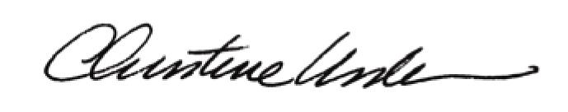

By:

Date of Meeting: May 16, 2016 Title: Historic Officer